Even Semester (2019)



**BINUS UNIVERSITY**



**BINUS INTERNATIONAL**



**Assignment Cover Letter**

**(Individual Work)**

|  |  |  |  |  |  |  |  |
| --- | --- | --- | --- | --- | --- | --- | --- |
|  |  | | |  |  |  |  |
| **Student Information**: | **Surname** | | |  |  | **Given Names**  1.Livander  2.Erizky Suryaputra | Student ID Number  2201796384  2201797052 |
| 1.  2. | Surya  Muhammad | |
|  |  |  |  |  |  |  |  |
| **Course Code** | **: COMP6571** |  |  |  |  | **Course Name** | **: Data Structure and Algorithm** |
| **Class** | **: L2AC** |  |  |  |  | **Name of Lecturer(s)** | **: Kartiko Putranto** |
|  |  |  |  |  |  |  |  |
| **Major** | **: CS** |  |  |  |  |  |  |
| **Title of Assignment**  (if any) | : Snake and Ladder |  |  |  |  |  |  |
| **Type of Assignment**    **Submission Pattern** | **: Final Project** | |  |  |  |  |  |
| **Due Date** | **: 29 - 06 - 2019** | |  |  |  | **Submission Date** | **: 29 – 06 -2019** |

The assignment should meet the below requirements.

**Table of Contents**

1. Problem description
2. Proposed alternative data structures to solve the problem and the analysis of how the choice structures can work to solve the problem
3. Theoretical analysis of the data structures (if chosen)
4. Program manual, how to execute (with screenshots)
5. Results of the execution.
6. Link to the application demo video (with max. length of 2 minutes)
7. Link to the GIT website

**Problem description**

First of all, people around us enjoy playing games, such as board games or console games, especially when the games can be played by in a multiplayer system. People like to be competitive with their friends, so we decided to make 4 fun multiplayer games which all of them are competitive games where you have to beat your friends in these games, not only that, We even made a game app that stores many games, we provide 4 fun games in this app. More importantly they are all multiplayer and can be launch by this game app, so we can play many games in this game app without downloading multiple games in our device.

Let us recognize the problem. Majority of the people around us enjoy board games, being at Chess or Monopoly. These games have been around since the old age where there were no electronic devices to use to play games. Nowadays, everyone has access to a mobile device or a computer, it is crazy how accessible it is. These board games have stood the test of time, after centuries of its existence, there are still an enormous amount of interest in these games. In this project, we have fused and combined the aspects if playing these fun and exciting board games with the current technological advancement. We manage to not only minimize the negatives of the board games such as lack of accessibility, time consuming to set up, not being able to pause mid-game while maintaining the aspect where the interest so drastically desire, the game itself. Furthermore, we have added the benefits of an electronic device that are able to tackle these drawbacks from a board game. On top of that, playing the board games, even though through a screen, enables people to reminisce about their old days. Playing these games. Brings back happy memories of them playing.

For our project we have created DUEL(game app) that contains (Snake and Ladder, Sneak Ninja, Raccoon Island, and Wild West Gun). These games still retains the fun aspects of a multiplayer board game while gaining a few benefits. These games are not just a games, but you will be needing much skills to be the winner. Snake and Ladder (will test your luck), Sneak Ninja (will test how fast your fingers are), Raccoon Island (will test how good you are at controlling and dodging something, it test your focus as well), and finally the Wild West Gun ( will test your reflexes). These are the project that we will discuss further below.

**How it works**

Each node inside the tree will contain a game instance and ready to be launched when needed. Each node has its own game that is unique and fun such as Snake and Ladder, Sneak Ninja, Racoon Island, and also Wild West Gun. With the incredibly clever tree design its so efficient to launch between games for instance.

**Snake and Ladder** : you and your friends are balls who want to get to the 100th node. You can move to the next node by rolling the dice and move as many as what the dice pops up. There are many stairs that can help you get to the higher nodes much faster, but be careful about snakes that will hunt you down and make you go back down to the snake’s tail. You will be the winner if you get to the 100th node first and be faster your friend by having a very good luck

**Sneak Ninja game** : You and your friends are having a mission in a dungeon prison which there is an ogre who is doing it’s ritual that you have to kill. While it is doing his ritual, you must sneak behind that ogre by pressing “*L”* for Player 1 and pressing “*A”* for Player 1,and kill that ogre before your friend kills that ogre first. You have hiding skills which will be activated shortly after you release your sneak key. Sometimes the ogre will turn around because that’s the ritual pattern, you must be hiding when the ogre turns around otherwise the ogre will chase you and hit you with it’s gigantic mace and you will be bounced off to where you begin because of that big hit by the ogre. Whoever kill the ogre first will win.

**Raccoon Island** : You and your friends are a raccoon that will running endlessly in Raccoon Island. What your objective is to run as far as you can while there are many traps and projectile that can crash you when you run, therefore you must avoid it while running by pressing “*W”* to jumpand *“S”* to crouch for Player 1 and “*Up Arrow”* to jumpand *“Down Arrow”* to crouchfor Player 2. Be the best raccoon, beat your friend, and you will win the game

**Wild West Gun** : You and your friends are a gun who shoots each other when the game told you to go. Nobody will die after getting shot but this is a game for testing who has the best reflexes. Shot first when the game told you to go and you win, You lose if you shot before the game told you to go

**Analysis**

Because making a game app that can launch many games inside it is a good example for using these data structures which is: tree.

**Screenshots**

(screenshot of the code)

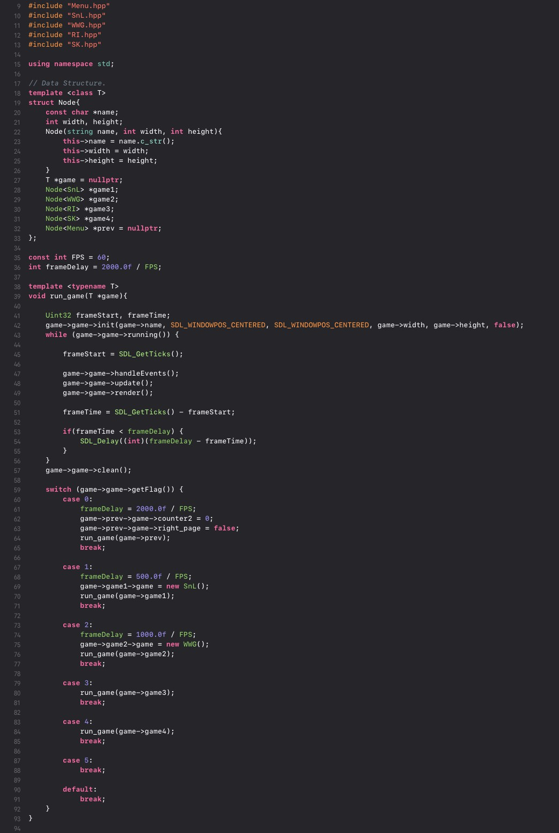

**Results**

(screenshot of the game)

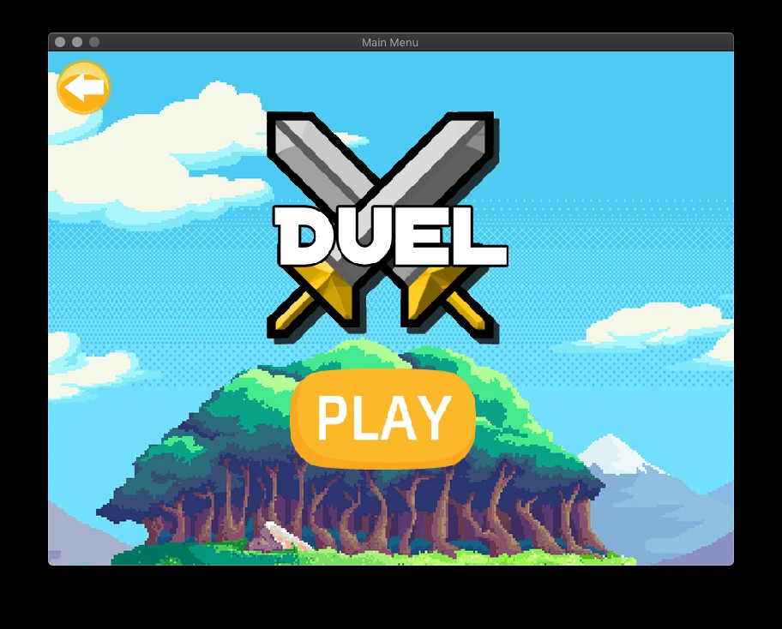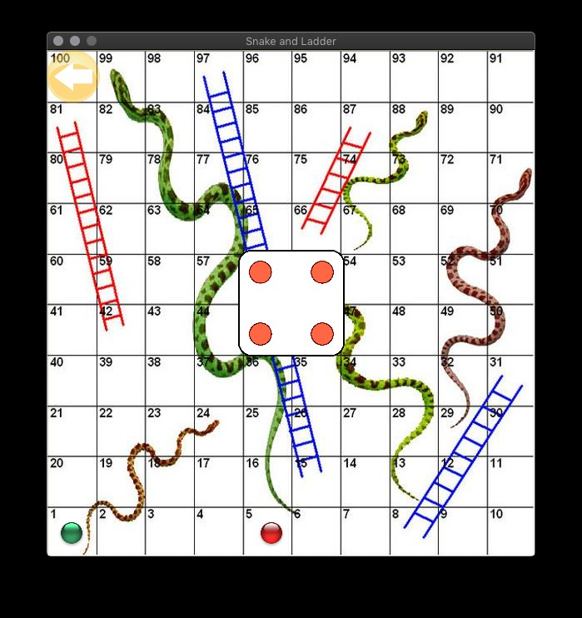

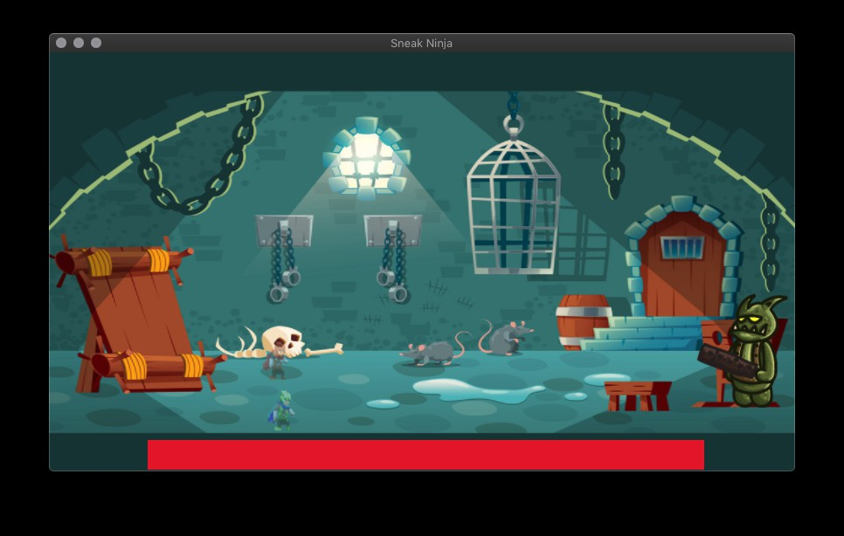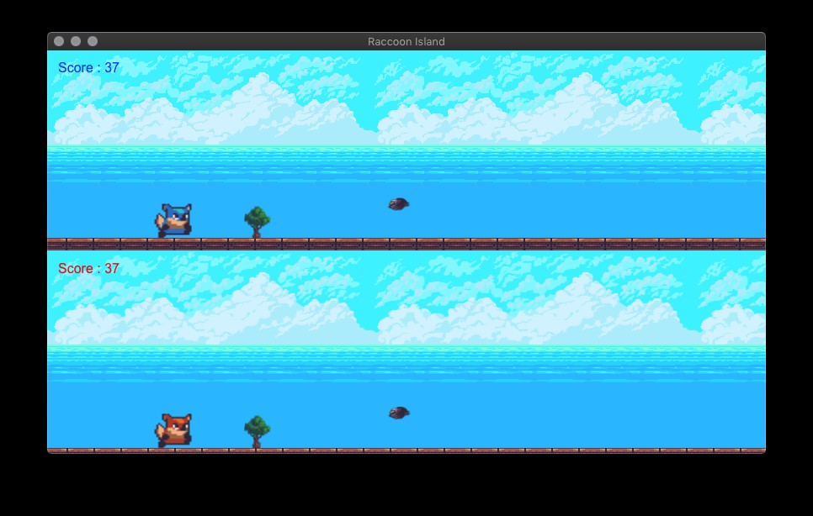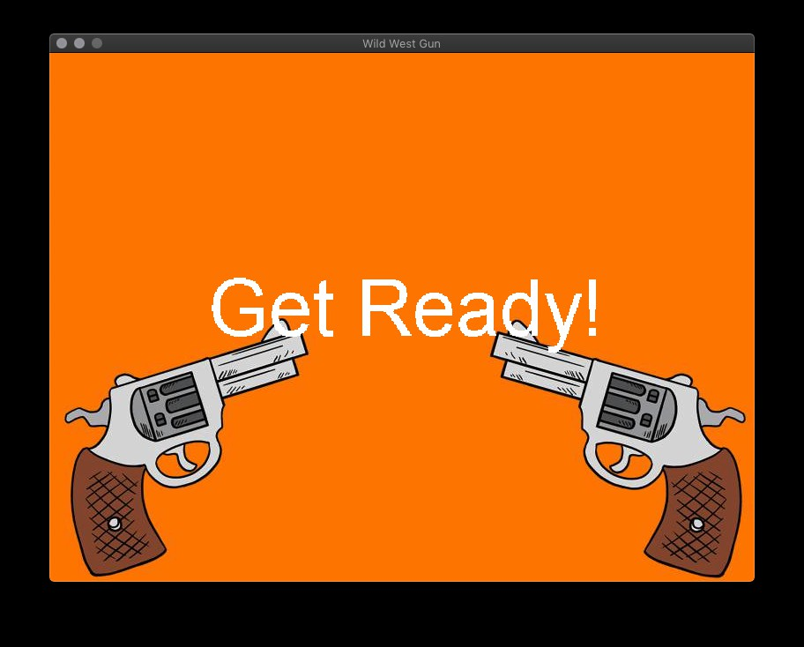

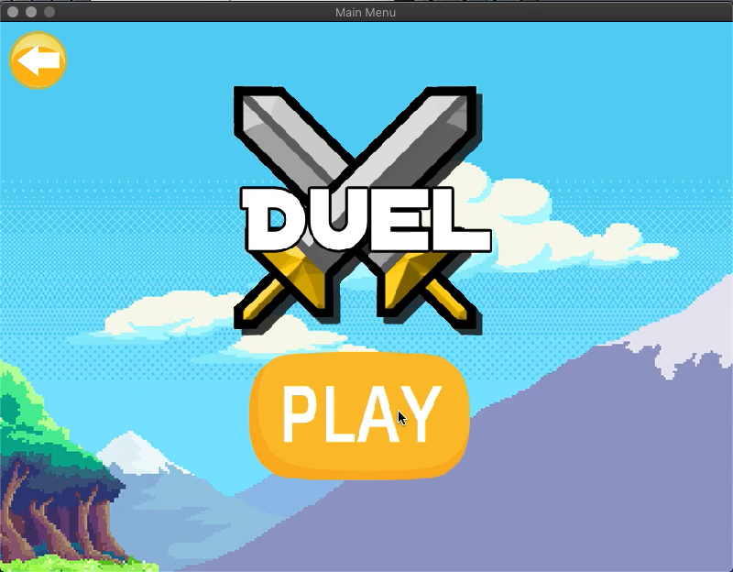**Video**

**Link**

https://github.com/savageRex/Duet